Mapping Museums – AB analysis

# Preliminary analysis

Note that high-res version of these figures are available in folder:

<https://www.dropbox.com/sh/ni2va07m7f7nkvk/AABTkKXqV5SoeyPUPYIx-xXma?dl=0>

What is the ID of a museum? Project.identifier is not unique: mm.domus.SC291 is duplicated.

I need to verify data from the DB:

* Tot museums in DB: 4063
* missing coordinates: 465
* Missing opening year: 1271 (+ 2 values = 9999)
* Missing closing year: 5555 (92); 9999 (2700); NA's (757); a few incorrect low values.
* Note: Wrong coordinates for mm.Mus70Cal.001

Very odd: London has the lowest number of museums per 100,000 people. Scotland has the highest. Why?

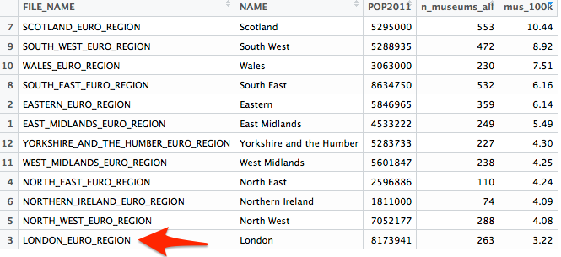

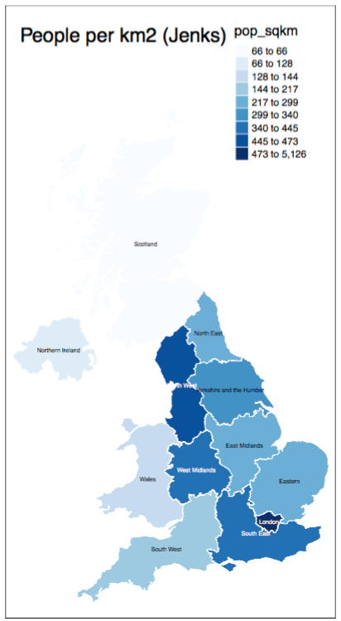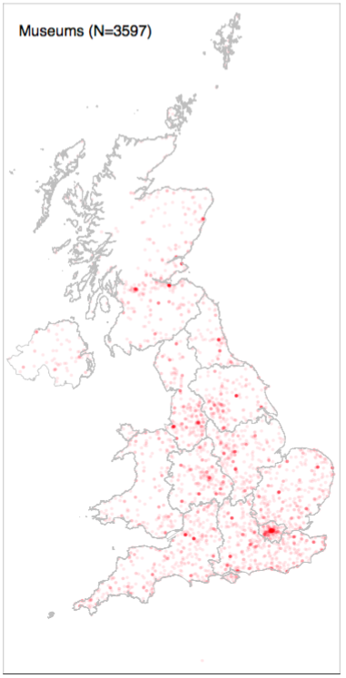

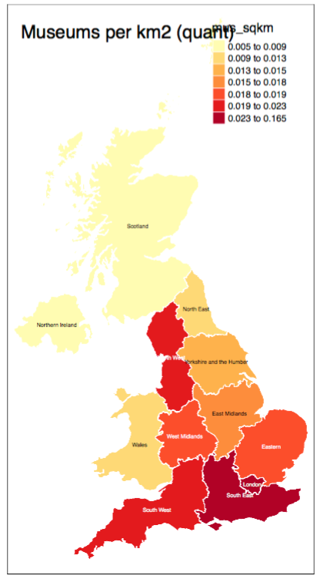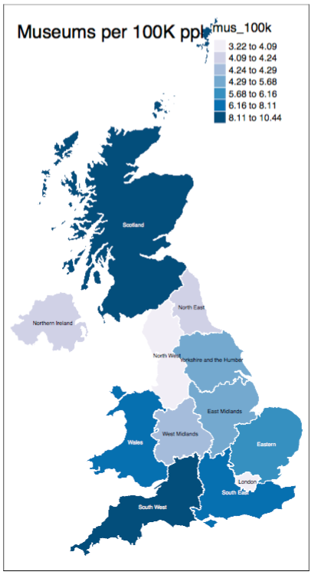

**Openings** and **closings** by **decade:**

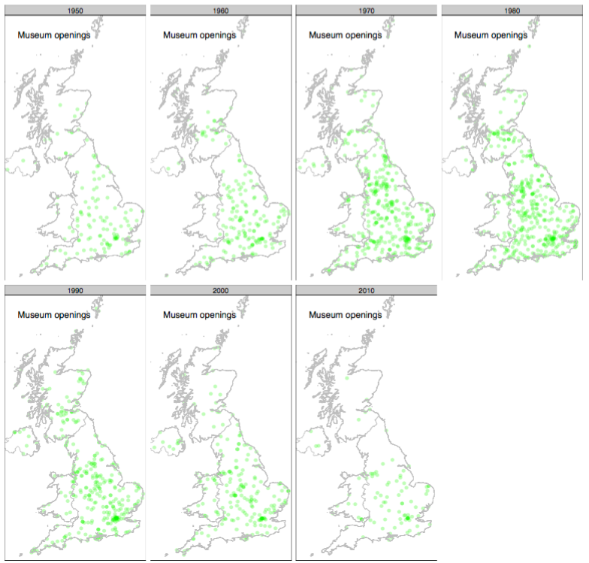

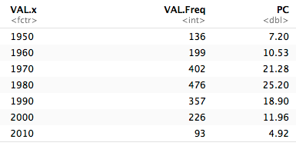

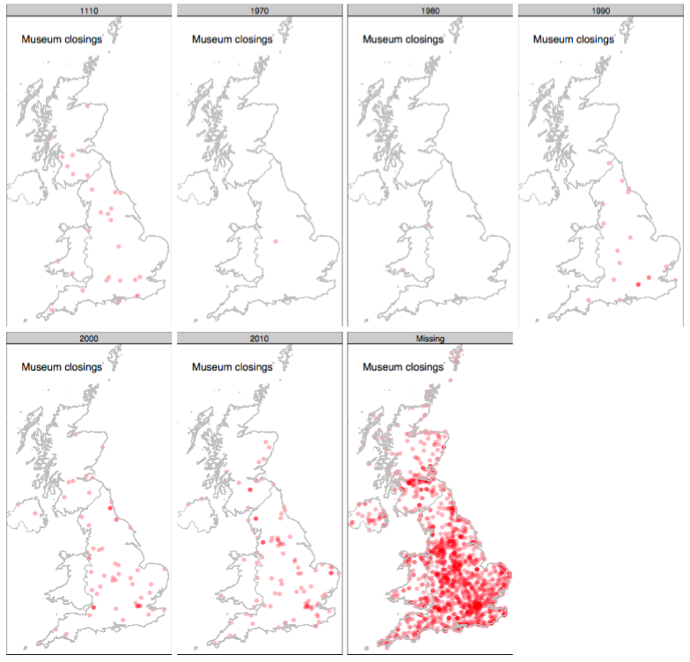

NA/missing values: 1667 (88.25%)

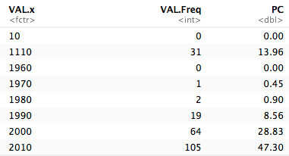

**Types (Classification 1998)**

NA/missing values: 975 (51.61%)

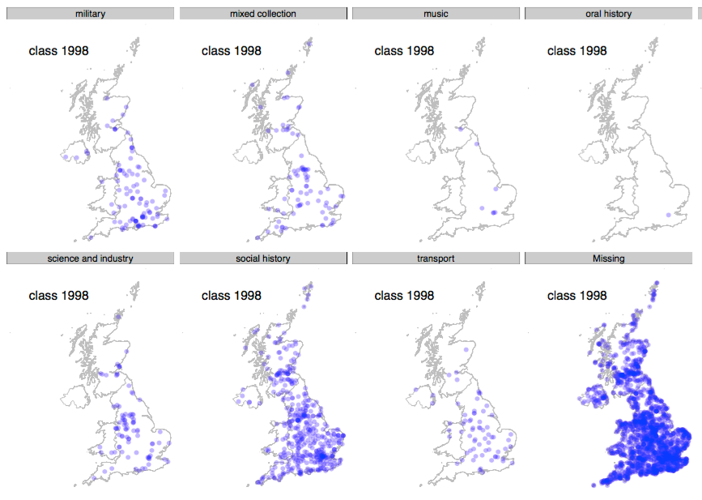

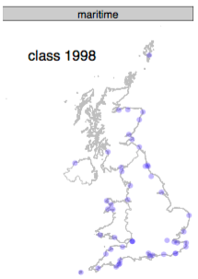

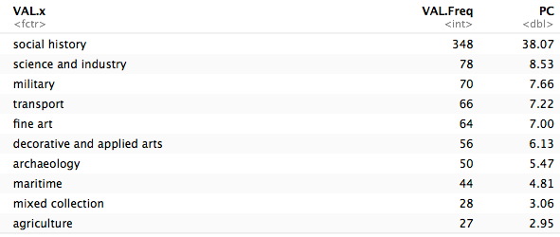

# Ideas for closure analysis

We have data about relatively few closures and their time and location (see figures above). I can highlight **areas** with an unexpectedly high closure rate. What are the **driving** **factors** of closures? Is there a geographic-social context that we can try to relate to it?

# Museum visits / size analysis

Data: 2443 museums; 4.5% museums without any visit info (**NA**). The NA museums are currently excluded from all charts and tables. Data is sparse, particularly in the 2000s. Present_PC is the percentage of museums with a data point. Better in the 1990s and 2010s:

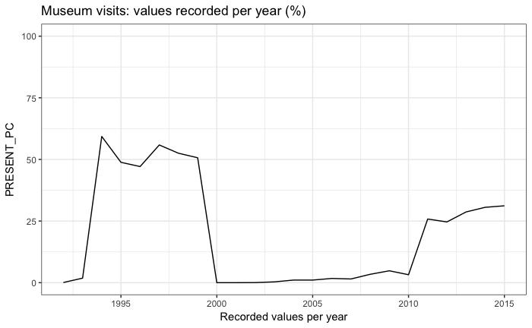

The last year data (i.e., the last known visit number for each museum) tends heavily to refer to 1999 and 2015:

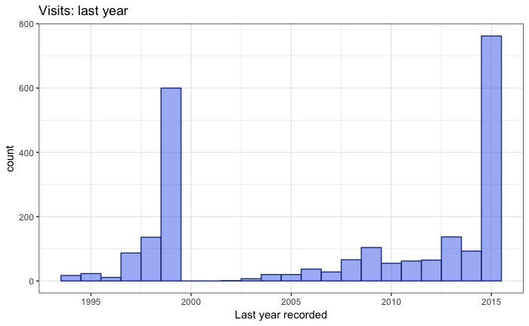

Most museums have either 1 year recorded, or 5-6. Relatively few have more than 7:

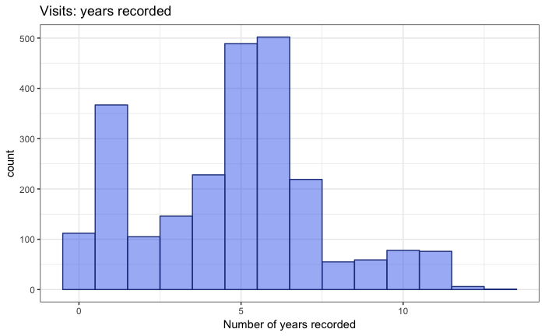

This is a summary of the **distribution of mean visits per year**.

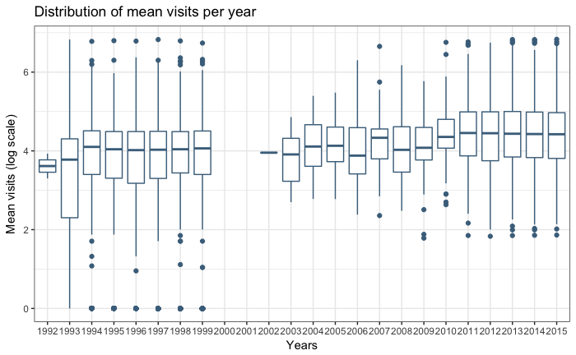

The **median of visits per year** shows an upward trend, suggesting that the data collected in 2010s covers larger museums (or that museum visits went up, but that is hard to tell):

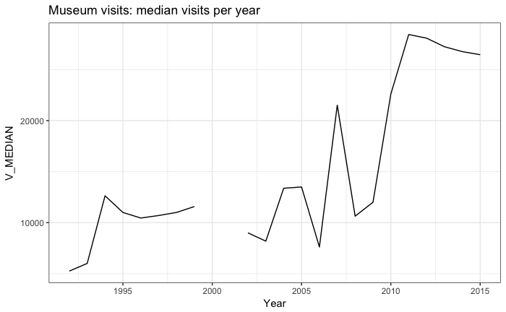

As expected, the mean data follows a power law, with most values being relatively low, and with a tail of few very large museums:

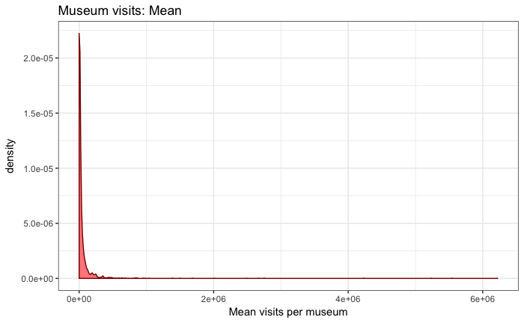

Note that **1e+06** means 1 million, **2e+06** 2 million, etc.

Hence, data can be better observed when logged in this histogram. The bump on the left is the **48 museums with visits = 0**.

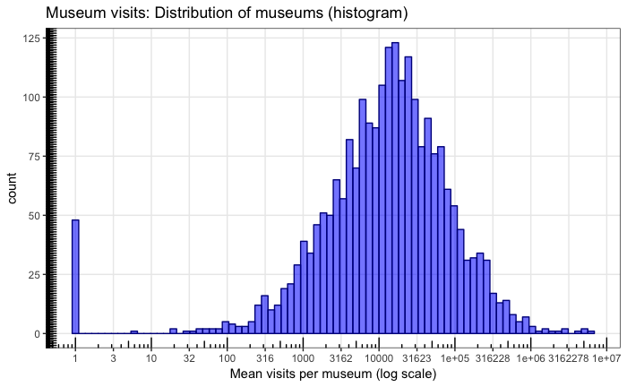

This distribution can be divided into **groups** using different strategies. The next plot shows the **quartiles**. This means 25% of museums have visits < 4097, 25% between 4097 and 13916, etc. The data has a clear peak around the median, showing that most museum (50%) fall between 4,000 and 40,000.

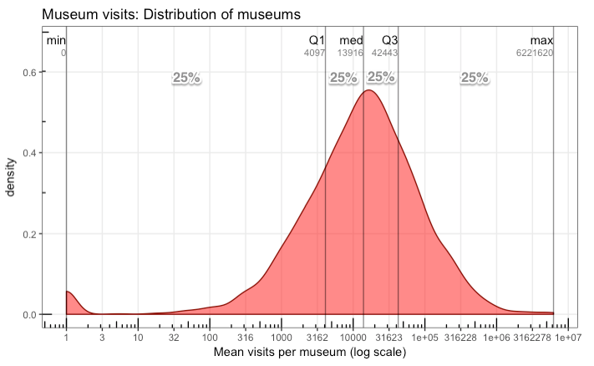

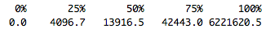

For the purpose of categorisation, it is better to use an even number of bins, for example with **tertiles**, which split the distribution into 3 blocks that contain 33% of the data (low, medium, high):

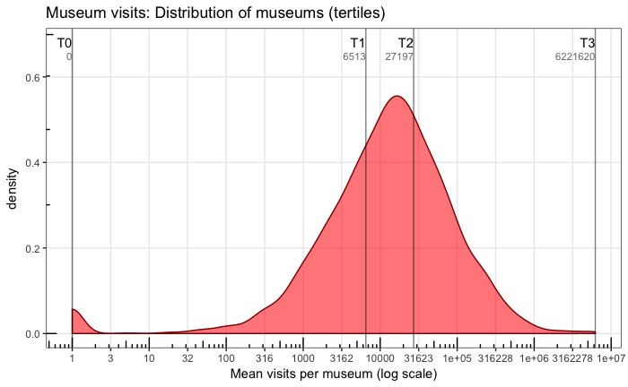

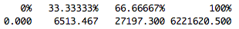

**Quintiles** follow the same idea, but with 5 classes:

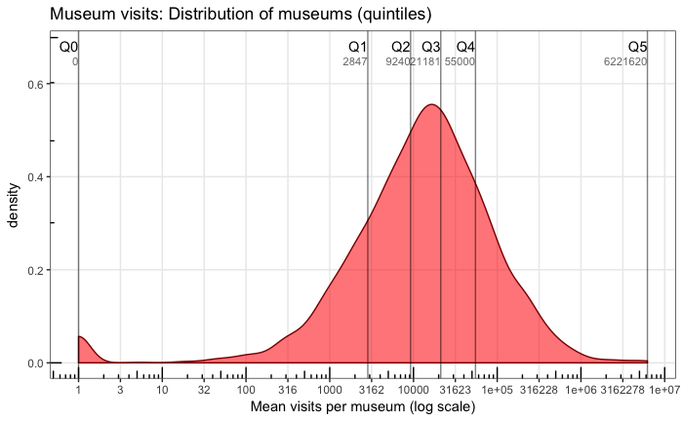

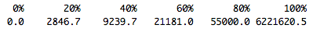

As the distribution is very wide (going from 0 to 6M), deciles might also be useful, with the following breaks. Each block has 10% of the data:

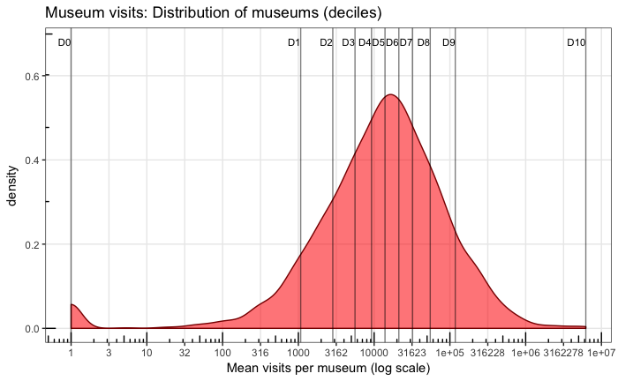



**Small museums (<10000)**: 48 museums have 0 as number of visits.

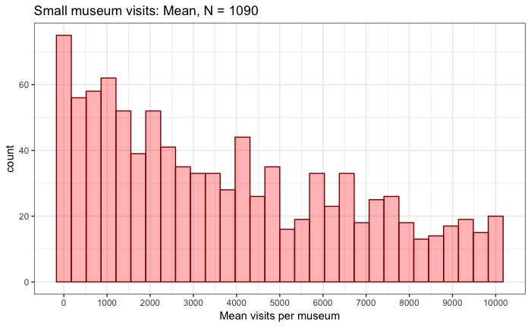

**Tiny museums (<1000)**: there are (few) museums in each bin, no gaps, so there is no reason to split them from the rest.

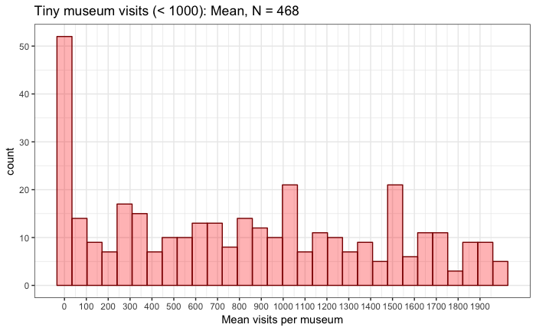

**Very large museums**: It is possible to note that after 1M visits, the distribution has a lot of gaps. This indicates that we might want a separate category, as these museums do not fit the rest of the distribution (e.g., “enormous”):

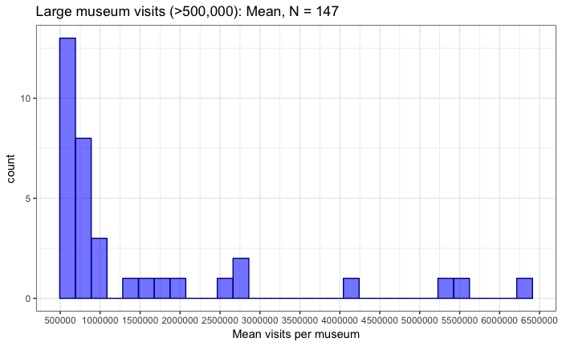

For the **size classification**, we have to decide which and how many classes we want. These are examples based on quintiles or tertiles above:

|  |  |  |  |
| --- | --- | --- | --- |
| *Size class* | *Visit range* (thousands) | *N museums* | *Example* |
| Unknown | <3? | 5% |  |
| Very small | 0-3 | 20% |  |
| Small | 3-9 | 20% |  |
| Medium | 9-20 | 20% |  |
| Large | 20-55 | 20% |  |
| Very large | 55-1M | 20% |  |
| Enormous | > 1M | 124 | British Museum |

Or

|  |  |  |  |
| --- | --- | --- | --- |
| *Size class* | *Visit range* (thousands) | *N museums* | *Example* |
| Unknown | <3? | 5% |  |
| Small | 0-6.5 | 33% |  |
| Medium | 6.5-27 | 33% |  |
| Large | 27-1M | 33% |  |
| Enormous | > 1M | 124 | British Museum |

This is just an example. It might be useful to relate the size to the governance or other aspects (but I only have the October data).

**Categories** suggested by Fiona.

Cats: "zero","tiny","very_small","small","medium","large","very_large","huge"

Cuts: c(-Inf, 0, 1, 5, 20, 50, 100, 1000, Inf)

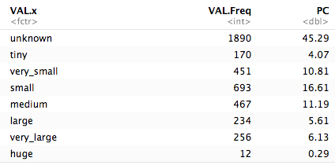

Plot of the classification (unknown omitted):

